COFFEE SHOP

PROJECT DESCRIPITION

Welcome to my cozy and inviting coffee shop, where the comfort and satisfaction of each guest is our top priority. Our stylish setting features rustic decor with warm and earthy tones, perfect for sipping a delicious coffee or tea. My project is to open a new coffee shop in a online community. The coffee shop will be designed to create a welcoming and warm atmosphere that encourages customers to stay longer and enjoy their coffee.

The primary goal of our shop is to provide high-quality coffee made from freshly roasted beans. We aim to differentiate our coffee shop from the competition by offering a unique blend of specialty coffee and high-quality food and pastries made on-site every day. We will also offer an extensive range of non-coffee drinks such as mochas, lattes, cappuccinos, and hot chocolate. Plus, we will offer tea and smoothies.

Our coffee shop will be designed for customers who value quality and appreciate attention to detail. We will prioritize locally sourced products to ensure that all of our ingredients are fresh and of the highest quality. Our friendly and knowledgeable staff will be dedicated to providing excellent customer service and will be trained to make every customer feel welcome and valued.

Our primary target market will be office workers, students, and customers who appreciate a high-quality coffee shop experience. We will use a combination of social media marketing, advertising, and word-of-mouth recommendations to reach our target audience.

Overall, our coffee shop project is designed to provide an exceptional coffee shop experience that combines high-quality products, excellent customer service, and a welcoming environment that our customers will love and want to visit time and time again.

Our menu features a wide variety of specialty coffees made from freshly roasted beans, handcrafted lattes, cappuccinos, and iced beverages. We also have a selection of organic and herbal teas, with something to suit every taste and occasion.

Our skilled baristas take great pride in the art of coffee making, ensuring that every cup is brewed to perfection. We use only the finest quality ingredients, including locally sourced milk and syrups, to create our signature drinks.

We look forward to seeing you soon.

CODE

INDEX.HTML

<html lang="en">

<head>

<meta charset="UTF-8">

<meta http-epuiv="X-UA-Compatible" content="IE-edge">

<meta name="viewport" content="width=device-width, initial-scale=1.0">

<title>Coffee Shop</title>

<link rel="stylesheet" href="style.css">

<!-- bootstrap link-->

<link href="https://cdn.jsdelivr.net/npm/bootstrap@5.0.2/dist/css/bootstrap.min.css" rel="stylesheet" integrity="sha384-EVSTQN3/azprG1Anm3QDgpJLIm9Nao0Yz1ztcQTwFspd3yD65VohhpuuCOmLASjC" crossorigin="anonymous">

<!-- bootstrap link-->

<!-- awesome fonts-->

<script src="https://kit.fontawesome.com/38eb5f35af.js" crossorigin="anonymous"></script>

<!-- awsome fonts-->

<!--google fonts-->

<link rel="preconnect" href="https://fonts.googleapis.com">

<link rel="preconnect" href="https://fonts.gstatic.com" crossorigin>

<link href="https://fonts.googleapis.com/css2?family=Roboto:wght@500&display=swap" rel="stylesheet">

<!--google fonts-->

</head>

<body>

<!--navbar starts--->

<nav class="navbar navbar-expand-lg fixed-top" id="navbar">

<div class="container-fluid">

<a class="navbar-brand" href="index.html"id="logo"><span>C</span>offee</a>

<button class="navbar-toggler" type="button" data-bs-toggle="collapse" data-bs-target="#mynavbar">

<span><i class="fa-solid fa-bars"> </i> </span>

</button>

<div class="collapse navbar-collapse" id="mynavbar">

<ul class="navbar-nav me-auto">

<li class="nav-item">

<a class="nav-link active" href="index.html">Home</a>

</li>

<li class="nav-item">

<a class="nav-link" href="register.html">Register</a>

</li>

<li class="nav-item">

<a class="nav-link" href="products.html">Products</a>

</li>

<li class="nav-item">

<a class="nav-link" href="services.html">Services</a>

</li>

<li class="nav-item">

<a class="nav-link" href="gallery.html">Gallery</a>

</li>

<li class="nav-item">

<a class="nav-link" href="about.html">About</a>

</li>

</ul>

<form class="d-flex">

<input class="form-control me-2" type="text" placeholder="Search">

<button class="btn btn-primary" type="button">Search</button>

</form>

</div>

</div>

</nav>

<!--navbar ends-->

<!-- home section starts-->

<div class="home">

<div class="content">

<h5>GOOD MORNING</h5>

<h1>Have <span class="changecontent"></span></h1>

<p>“LOVE IS IN THE AIR AND IT SMELLS LIKE COFFEE”. </p>

<a href="#book">VISIT NOW</a>

</div>

</div>

<!-- home section starts-->

REGISTER.HTML

<html lang="en">

<head>

<meta charset="UTF-8">

<meta http-epuiv="X-UA-Compatible" content="IE-edge">

<meta name="viewport" content="width=device-width, initial-scale=1.0">

<title>Coffee Shop</title>

<link rel="stylesheet" href="style.css">

<!-- bootstrap link-->

<link href="https://cdn.jsdelivr.net/npm/bootstrap@5.0.2/dist/css/bootstrap.min.css" rel="stylesheet" integrity="sha384-EVSTQN3/azprG1Anm3QDgpJLIm9Nao0Yz1ztcQTwFspd3yD65VohhpuuCOmLASjC" crossorigin="anonymous">

<!-- bootstrap link-->

<!-- awesome fonts-->

<script src="https://kit.fontawesome.com/38eb5f35af.js" crossorigin="anonymous"></script>

<!-- awsome fonts-->

<!--google fonts-->

<link rel="preconnect" href="https://fonts.googleapis.com">

<link rel="preconnect" href="https://fonts.gstatic.com" crossorigin>

<link href="https://fonts.googleapis.com/css2?family=Roboto:wght@500&display=swap" rel="stylesheet">

<!--google fonts-->

</head>

<body>

<!--navbar starts--->

<nav class="navbar navbar-expand-lg fixed-top" id="navbar">

<div class="container-fluid">

<a class="navbar-brand" href="index.html"id="logo"><span>C</span>offee</a>

<button class="navbar-toggler" type="button" data-bs-toggle="collapse" data-bs-target="#mynavbar">

<span><i class="fa-solid fa-bars"> </i> </span>

</button>

<div class="collapse navbar-collapse" id="mynavbar">

<ul class="navbar-nav me-auto">

<li class="nav-item">

<a class="nav-link active" href="index.html">Home</a>

</li>

<li class="nav-item">

<a class="nav-link" href="register.html">Register</a>

</li>

<li class="nav-item">

<a class="nav-link" href="products.html">Products</a>

</li>

<li class="nav-item">

<a class="nav-link" href="services.html">Services</a>

</li>

<li class="nav-item">

<a class="nav-link" href="gallery.html">Gallery</a>

</li>

<li class="nav-item">

<a class="nav-link" href="about.html">About</a>

</li>

</ul>

<form class="d-flex">

<input class="form-control me-2" type="text" placeholder="Search">

<button class="btn btn-primary" type="button">Search</button>

</form>

</div>

</div>

</nav>

<!--navbar ends-->

<!--section register starts -->

<section class="register" id="register">

<div class="container">

<div class="main-text">

<h1><span>R</span>EGISTER</h1>

</div>

<div class="row">

<div class="col-md-6 py-3 py-md-0">

<div class="card">

<img src="./img/cof (1).jpeg" alt="">

</div>

</div>

<div class="col-md-6 py-3 py-md-0">

<form action="#">

<input type="text" class="form-control" placeholder="NAME" required><br>

<input type="text" class="form-control" placeholder="EMAIL" required><br>

<input type="text" class="form-control" placeholder="PHONE NUMBER" required><br>

<textarea class="form-control" rows="5" name="text" placeholder="ENTER YOUR ADDRESS"></textarea>

<input type="submit" value="Create A Account" class="submit"required>

</form>

</div>

</div>

</div>

</section>

<!--section register ends -->

<!--footer starts-->

<footer id="footer">

<h1><span>C</span>OFFEE</h1>

<p>THANK YOU</p>

<div class="social-links">

<i class="fa-brands fa-twitter"></i>

<i class="fa-brands fa-facebook"></i>

<i class="fa-brands fa-instagram"></i>

<i class="fa-brands fa-youtube"></i>

<i class="fa-brands fa-pinterest-p"></i>

</div>

<div class="credit">

<p>Designed By<a href=#> SUBHA</a></p>

</div>

<div class="copyright">

<p>&copy;Copyright SUBHASHNI.All Rights Reserved</p>

</div>

</footer>

<!--footer starts-->

<script src="https://cdn.jsdelivr.net/npm/bootstrap@5.0.2/dist/js/bootstrap.bundle.min.js" integrity="sha384-MrcW6ZMFYlzcLA8Nl+NtUVF0sA7MsXsP1UyJoMp4YLEuNSfAP+JcXn/tWtIaxVXM" crossorigin="anonymous"></script>

</body>

</html>

</body>

</html>

PRODUCTS.HTML

<html lang="en">

<head>

<meta charset="UTF-8">

<meta http-epuiv="X-UA-Compatible" content="IE-edge">

<meta name="viewport" content="width=device-width, initial-scale=1.0">

<title>Coffee Shop</title>

<link rel="stylesheet" href="style.css">

<!-- bootstrap link-->

<link href="https://cdn.jsdelivr.net/npm/bootstrap@5.0.2/dist/css/bootstrap.min.css" rel="stylesheet" integrity="sha384-EVSTQN3/azprG1Anm3QDgpJLIm9Nao0Yz1ztcQTwFspd3yD65VohhpuuCOmLASjC" crossorigin="anonymous">

<!-- bootstrap link-->

<!-- awesome fonts-->

<script src="https://kit.fontawesome.com/38eb5f35af.js" crossorigin="anonymous"></script>

<!-- awsome fonts-->

<!--google fonts-->

<link rel="preconnect" href="https://fonts.googleapis.com">

<link rel="preconnect" href="https://fonts.gstatic.com" crossorigin>

<link href="https://fonts.googleapis.com/css2?family=Roboto:wght@500&display=swap" rel="stylesheet">

<!--google fonts-->

</head>

<body>

<!--navbar starts--->

<nav class="navbar navbar-expand-lg fixed-top" id="navbar">

<div class="container-fluid">

<a class="navbar-brand" href="index.html"id="logo"><span>C</span>offee</a>

<button class="navbar-toggler" type="button" data-bs-toggle="collapse" data-bs-target="#mynavbar">

<span><i class="fa-solid fa-bars"> </i> </span>

</button>

<div class="collapse navbar-collapse" id="mynavbar">

<ul class="navbar-nav me-auto">

<li class="nav-item">

<a class="nav-link active" href="index.html">Home</a>

</li>

<li class="nav-item">

<a class="nav-link" href="register.html">Register</a>

</li>

<li class="nav-item">

<a class="nav-link" href="products.html">Products</a>

</li>

<li class="nav-item">

<a class="nav-link" href="services.html">Services</a>

</li>

<li class="nav-item">

<a class="nav-link" href="gallery.html">Gallery</a>

</li>

<li class="nav-item">

<a class="nav-link" href="about.html">About</a>

</li>

</ul>

<form class="d-flex">

<input class="form-control me-2" type="text" placeholder="Search">

<button class="btn btn-primary" type="button">Search</button>

</form>

</div>

</div>

</nav>

<!--navbar ends-->

<!--section products start-->

<section class="products" id="products">

<div class="container">

<div class="main-txt">

<h1><span>P</span>RODUCTS</h1>

</div>

<div class="row" style="margin-top: 30px;">

<div class="col-md-4 py-3 py-md-0">

<div class="card">

<img src="./img/Doppio.jpg" alt="">

<div class="card-body">

<h3>DOPPIO</h3>

<p>2 shots of hand-crafted espresso</p>

<div class="star">

<span class="fa fa-star checked"></span>

<span class="fa fa-star checked"></span>

<span class="fa fa-star checked"></span>

<span class="fa fa-star chacked"></span>

<span class="fa fa-star"></span>

</div>

<h6>price:<strong>$500</strong></h6>

<a href="#book">BUY</a>

</div>

</div>

</div>

<div class="col-md-4 py-3 py-md-0">

<div class="card">

<img src="./img/macchiato 1" alt="">

<div class="card-body">

<h3>Macchiato</h3>

<p>2 shots of hand-crafted espresso with a dollop of foamed milk</p>

<div class="star">

<span class="fa fa-star checked"></span>

<span class="fa fa-star checked"></span>

<span class="fa fa-star checked"></span>

<span class="fa fa-star"></span>

<span class="fa fa-star"></span>

</div>

<h6>price:<strong>$500</strong></h6>

<a href="#book">BUY</a>

</div>

</div>

</div>

<div class="col-md-4 py-3 py-md-0">

<div class="card">

<img src="./img/cona pana.jpg" alt="">

<div class="card-body">

<h3>Con Panna</h3>

<p>2 shots of hand-crafted espresso with house-made whip cream</p>

<div class="star">

<span class="fa fa-star checked"></span>

<span class="fa fa-star checked"></span>

<span class="fa fa-star checked"></span>

<span class="fa fa-star"></span>

<span class="fa fa-star"></span>

</div>

<h6>price:<strong>$500</strong></h6>

<a href="#book">BUY</a>

</div>

</div>

</div>

<div class="col-md-4 py-3 py-md-0">

<div class="card">

<img src="./img/cor.jpg" alt="">

<div class="card-body">

<h3>Cortado</h3>

<p>2 shots of hand-crafted espresso with 4 oz of steamed milk and foam</p>

<div class="star">

<span class="fa fa-star checked"></span>

<span class="fa fa-star checked"></span>

<span class="fa fa-star checked"></span>

<span class="fa fa-star"></span>

<span class="fa fa-star"></span>

</div>

<h6>price:<strong>$500</strong></h6>

<a href="#book">BUY</a>

</div>

</div>

</div>

<div class="col-md-4 py-3 py-md-0">

<div class="card">

<img src="./img/cap.jpg" alt="">

<div class="card-body">

<h3>Cappuccino</h3>

<p>2 shots of hand-crafted espresso with foam</p>

<div class="star">

<span class="fa fa-star checked"></span>

<span class="fa fa-star checked"></span>

<span class="fa fa-star checked"></span>

<span class="fa fa-star"></span>

<span class="fa fa-star"></span>

</div>

<h6>price:<strong>$500</strong></h6>

<a href="#book">BUY</a>

</div>

</div>

</div>

<div class="col-md-4 py-3 py-md-0">

<div class="card">

<img src="./img/hot.jpg" alt="">

<div class="card-body">

<h3>Hot Chocolate</h3>

<p>5 Sparrows House Chocolate, from Montana and steamed milk!</p>

<div class="star">

<span class="fa fa-star checked"></span>

<span class="fa fa-star checked"></span>

<span class="fa fa-star checked"></span>

<span class="fa fa-star"></span>

<span class="fa fa-star"></span>

</div>

<h6>price:<strong>$500</strong></h6>

<a href="#book">BUY</a>

</div>

</div>

</div>

<div class="col-md-4 py-3 py-md-0">

<div class="card">

<img src="./img/am.jpeg" alt="">

<div class="card-body">

<h3>Americano</h3>

<p>2 shots of hand-crafted espresso and hot water</p>

<div class="star">

<span class="fa fa-star checked"></span>

<span class="fa fa-star checked"></span>

<span class="fa fa-star checked"></span>

<span class="fa fa-star"></span>

<span class="fa fa-star"></span>

</div>

<h6>price:<strong>$500</strong></h6>

<a href="#book">BUY</a>

</div>

</div>

</div>

<div class="col-md-4 py-3 py-md-0">

<div class="card">

<img src="./img/lat.jpeg" alt="">

<div class="card-body">

<h3>Latte</h3>

<p>2 shots of hand-crafted espresso and steamed milk</p>

<div class="star">

<span class="fa fa-star checked"></span>

<span class="fa fa-star checked"></span>

<span class="fa fa-star checked"></span>

<span class="fa fa-star"></span>

<span class="fa fa-star"></span>

</div>

<h6>price:<strong>$500</strong></h6>

<a href="#book">BUY</a>

</div>

</div>

</div>

<div class="col-md-4 py-3 py-md-0">

<div class="card">

<img src="./img/cof (5).jpeg" alt="">

<div class="card-body">

<h3>Latte + FLAVOR</h3>

<P>Vanilla / Hazelnut / Almond / Caramel / White Chocolate</P>

<div class="star">

<span class="fa fa-star checked"></span>

<span class="fa fa-star checked"></span>

<span class="fa fa-star checked"></span>

<span class="fa fa-star"></span>

<span class="fa fa-star"></span>

</div>

<h6>price:<strong>$500</strong></h6>

<a href="#book">BUY</a>

</div>

</div>

</div>

<div class="col-md-4 py-3 py-md-0">

<div class="card">

<img src="./img/mocha.jpg" alt="">

<div class="card-body">

<h3>Mocha</h3>

<p>2 shots of hand-crafted espresso, steamed milk and house chocolate</p>

<div class="star">

<span class="fa fa-star checked"></span>

<span class="fa fa-star checked"></span>

<span class="fa fa-star checked"></span>

<span class="fa fa-star"></span>

<span class="fa fa-star"></span>

</div>

<h6>price:<strong>$500</strong></h6>

<a href="#book">BUY</a>

</div>

</div>

</div>

<div class="col-md-4 py-3 py-md-0">

<div class="card">

<img src="./img/chai.jpg" alt="">

<div class="card-body">

<h3>Chai Latte</h3>

<p>5 Sparrows Chai, from Montana and steamed milk make for a perfect balance of sweet and spice.</p>

<div class="star">

<span class="fa fa-star checked"></span>

<span class="fa fa-star checked"></span>

<span class="fa fa-star checked"></span>

<span class="fa fa-star"></span>

<span class="fa fa-star"></span>

</div>

<h6>price:<strong>$500</strong></h6>

<a href="#book">BUY</a>

</div>

</div>

</div>

<div class="col-md-4 py-3 py-md-0">

<div class="card">

<img src="./img/tea.jpg" alt="">

<div class="card-body">

<h3>Tea</h3>

<p>Flying Bird Botanicals Tea, from Bellingham, WA!</p>

<div class="star">

<span class="fa fa-star checked"></span>

<span class="fa fa-star checked"></span>

<span class="fa fa-star checked"></span>

<span class="fa fa-star"></span>

<span class="fa fa-star"></span>

</div>

<h6>price:<strong>$500</strong></h6>

<a href="#book">BUY</a>

</div>

</div>

</div>

</div>

</div>

<div>

<!-- Add icon library -->

<link rel="stylesheet" href="https://cdnjs.cloudflare.com/ajax/libs/font-awesome/4.7.0/css/font-awesome.min.css">

</div>

</section>

<!--section products end-->

<!--footer starts-->

<footer id="footer">

<h1><span>C</span>OFFEE</h1>

<p>THANK YOU</p>

<div class="social-links">

<i class="fa-brands fa-twitter"></i>

<i class="fa-brands fa-facebook"></i>

<i class="fa-brands fa-instagram"></i>

<i class="fa-brands fa-youtube"></i>

<i class="fa-brands fa-pinterest-p"></i>

</div>

<div class="credit">

<p>Designed By<a href=#> SUBHA</a></p>

</div>

<div class="copyright">

<p>&copy;Copyright SUBHASHNI.All Rights Reserved</p>

</div>

</footer>

<!--footer starts-->

<script src="https://cdn.jsdelivr.net/npm/bootstrap@5.0.2/dist/js/bootstrap.bundle.min.js" integrity="sha384-MrcW6ZMFYlzcLA8Nl+NtUVF0sA7MsXsP1UyJoMp4YLEuNSfAP+JcXn/tWtIaxVXM" crossorigin="anonymous"></script>

</body>

</html>

SERVICES.HTML

<html lang="en">

<head>

<meta charset="UTF-8">

<meta http-epuiv="X-UA-Compatible" content="IE-edge">

<meta name="viewport" content="width=device-width, initial-scale=1.0">

<title>Coffee Shop</title>

<link rel="stylesheet" href="style.css">

<!-- bootstrap link-->

<link href="https://cdn.jsdelivr.net/npm/bootstrap@5.0.2/dist/css/bootstrap.min.css" rel="stylesheet" integrity="sha384-EVSTQN3/azprG1Anm3QDgpJLIm9Nao0Yz1ztcQTwFspd3yD65VohhpuuCOmLASjC" crossorigin="anonymous">

<!-- bootstrap link-->

<!-- awesome fonts-->

<script src="https://kit.fontawesome.com/38eb5f35af.js" crossorigin="anonymous"></script>

<!-- awsome fonts-->

<!--google fonts-->

<link rel="preconnect" href="https://fonts.googleapis.com">

<link rel="preconnect" href="https://fonts.gstatic.com" crossorigin>

<link href="https://fonts.googleapis.com/css2?family=Roboto:wght@500&display=swap" rel="stylesheet">

<!--google fonts-->

</head>

<body>

<!--navbar starts--->

<nav class="navbar navbar-expand-lg fixed-top" id="navbar">

<div class="container-fluid">

<a class="navbar-brand" href="index.html"id="logo"><span>C</span>offee</a>

<button class="navbar-toggler" type="button" data-bs-toggle="collapse" data-bs-target="#mynavbar">

<span><i class="fa-solid fa-bars"> </i> </span>

</button>

<div class="collapse navbar-collapse" id="mynavbar">

<ul class="navbar-nav me-auto">

<li class="nav-item">

<a class="nav-link active" href="index.html">Home</a>

</li>

<li class="nav-item">

<a class="nav-link" href="register.html">Register</a>

</li>

<li class="nav-item">

<a class="nav-link" href="products.html">Products</a>

</li>

<li class="nav-item">

<a class="nav-link" href="services.html">Services</a>

</li>

<li class="nav-item">

<a class="nav-link" href="gallery.html">Gallery</a>

</li>

<li class="nav-item">

<a class="nav-link" href="about.html">About</a>

</li>

</ul>

<form class="d-flex">

<input class="form-control me-2" type="text" placeholder="Search">

<button class="btn btn-primary" type="button">Search</button>

</form>

</div>

</div>

</nav>

<!--navbar ends-->

<!--section serives starts-->

<section class="services" id="services">

<div class="container">

<div class="main-txt">

<h1><span>S</span>ervices</h1>

</div>

<div class="row" style="margin-top: 30px;">

<div class="col-md-4 py-3 py-md-0>">

<div class="card">

<i class="fa-solid fa-thumbs-up"></i>

<div class="card-body">

<h3>QUALITY PRODUCTS</h3>

</div>

</div>

</div>

<div class="col-md-4 py-3 py-md-0>">

<div class="card">

<i class="fas fa-bullhorn"></i>

<div class="card-body">

<h3>BEST ITEMS</h3>

</div>

</div>

</div>

<div class="col-md-4 py-3 py-md-0>">

<div class="card">

<i class="fa-solid fa-star"></i>

<div class="card-body">

<h3>STAR RATING</h3>

</div>

</div>

</div>

</div>

</div>

</section>

<!--section serives ends-->

<!--footer starts-->

<footer id="footer">

<h1><span>C</span>OFFEE</h1>

<p>THANK YOU</p>

<div class="social-links">

<i class="fa-brands fa-twitter"></i>

<i class="fa-brands fa-facebook"></i>

<i class="fa-brands fa-instagram"></i>

<i class="fa-brands fa-youtube"></i>

<i class="fa-brands fa-pinterest-p"></i>

</div>

<div class="credit">

<p>Designed By<a href=#> SUBHA</a></p>

</div>

<div class="copyright">

<p>&copy;Copyright SUBHASHNI.All Rights Reserved</p>

</div>

</footer>

<!--footer starts-->

</body>

GALLERY.HTML

<html lang="en">

<head>

<meta charset="UTF-8">

<meta http-epuiv="X-UA-Compatible" content="IE-edge">

<meta name="viewport" content="width=device-width, initial-scale=1.0">

<title>Coffee Shop</title>

<link rel="stylesheet" href="style.css">

<!-- bootstrap link-->

<link href="https://cdn.jsdelivr.net/npm/bootstrap@5.0.2/dist/css/bootstrap.min.css" rel="stylesheet" integrity="sha384-EVSTQN3/azprG1Anm3QDgpJLIm9Nao0Yz1ztcQTwFspd3yD65VohhpuuCOmLASjC" crossorigin="anonymous">

<!-- bootstrap link-->

<!-- awesome fonts-->

<script src="https://kit.fontawesome.com/38eb5f35af.js" crossorigin="anonymous"></script>

<!-- awsome fonts-->

<!--google fonts-->

<link rel="preconnect" href="https://fonts.googleapis.com">

<link rel="preconnect" href="https://fonts.gstatic.com" crossorigin>

<link href="https://fonts.googleapis.com/css2?family=Roboto:wght@500&display=swap" rel="stylesheet">

<!--google fonts-->

</head>

<body>

<!--navbar starts--->

<nav class="navbar navbar-expand-lg fixed-top" id="navbar">

<div class="container-fluid">

<a class="navbar-brand" href="index.html"id="logo"><span>C</span>offee</a>

<button class="navbar-toggler" type="button" data-bs-toggle="collapse" data-bs-target="#mynavbar">

<span><i class="fa-solid fa-bars"> </i> </span>

</button>

<div class="collapse navbar-collapse" id="mynavbar">

<ul class="navbar-nav me-auto">

<li class="nav-item">

<a class="nav-link active" href="index.html">Home</a>

</li>

<li class="nav-item">

<a class="nav-link" href="register.html">Register</a>

</li>

<li class="nav-item">

<a class="nav-link" href="products.html">Products</a>

</li>

<li class="nav-item">

<a class="nav-link" href="services.html">Services</a>

</li>

<li class="nav-item">

<a class="nav-link" href="gallery.html">Gallery</a>

</li>

<li class="nav-item">

<a class="nav-link" href="about.html">About</a>

</li>

</ul>

<form class="d-flex">

<input class="form-control me-2" type="text" placeholder="Search">

<button class="btn btn-primary" type="button">Search</button>

</form>

</div>

</div>

</nav>

<!--navbar ends-->

<!--section gallery starts-->

<section class="gallery" id="gallery">

<div class="contanier">

<div class="main-txt">

<h1><span>G</span>allery</h1>

</div>

<div class="row" style="margin-top: 30px;">

<div class="col-md-4 py-3 py-md-0">

<div class="card">

<img src="./img/cof (2).jpeg" alt="" height="230px">

</div>

</div>

<div class="col-md-4 py-3 py-md-0">

<div class="card">

<img src="./img/c (2).jpeg" alt="" height="230px">

</div>

</div>

<div class="col-md-4 py-3 py-md-0">

<div class="card">

<img src="./img/c (3).jpeg" alt="" height="230px">

</div>

</div>

</div>

<div class="row" style="margin-top: 30px;">

<div class="col-md-4 py-3 py-md-0">

<div class="card">

<img src="./img/cof (5).jpeg" alt="" height="230px">

</div>

</div>

<div class="col-md-4 py-3 py-md-0">

<div class="card">

<img src="./img/coffeee.jpg" alt="" height="230px">

</div>

</div>

<div class="col-md-4 py-3 py-md-0">

<div class="card">

<img src="./img/coffee.jpeg" alt="" height="230px">

</div>

</div>

</div>

</div>

</section>

<!--section gallery starts-->

<!--footer starts-->

<footer id="footer">

<h1><span>C</span>OFFEE</h1>

<p>THANK YOU</p>

<div class="social-links">

<i class="fa-brands fa-twitter"></i>

<i class="fa-brands fa-facebook"></i>

<i class="fa-brands fa-instagram"></i>

<i class="fa-brands fa-youtube"></i>

<i class="fa-brands fa-pinterest-p"></i>

</div>

<div class="credit">

<p>Designed By<a href=#> SUBHA</a></p>

</div>

<div class="copyright">

<p>&copy;Copyright SUBHASHNI.All Rights Reserved</p>

</div>

</footer>

<!--footer starts-->

<script src="https://cdn.jsdelivr.net/npm/bootstrap@5.0.2/dist/js/bootstrap.bundle.min.js" integrity="sha384-MrcW6ZMFYlzcLA8Nl+NtUVF0sA7MsXsP1UyJoMp4YLEuNSfAP+JcXn/tWtIaxVXM" crossorigin="anonymous"></script>

</body>

</html>

ABOUT.HTML

<html lang="en">

<head>

<meta charset="UTF-8">

<meta http-epuiv="X-UA-Compatible" content="IE-edge">

<meta name="viewport" content="width=device-width, initial-scale=1.0">

<title>Coffee Shop</title>

<link rel="stylesheet" href="style.css">

<!-- bootstrap link-->

<link href="https://cdn.jsdelivr.net/npm/bootstrap@5.0.2/dist/css/bootstrap.min.css" rel="stylesheet" integrity="sha384-EVSTQN3/azprG1Anm3QDgpJLIm9Nao0Yz1ztcQTwFspd3yD65VohhpuuCOmLASjC" crossorigin="anonymous">

<!-- bootstrap link-->

<!-- awesome fonts-->

<script src="https://kit.fontawesome.com/38eb5f35af.js" crossorigin="anonymous"></script>

<!-- awsome fonts-->

<!--google fonts-->

<link rel="preconnect" href="https://fonts.googleapis.com">

<link rel="preconnect" href="https://fonts.gstatic.com" crossorigin>

<link href="https://fonts.googleapis.com/css2?family=Roboto:wght@500&display=swap" rel="stylesheet">

<!--google fonts-->

</head>

<body>

<!--navbar starts--->

<nav class="navbar navbar-expand-lg fixed-top" id="navbar">

<div class="container-fluid">

<a class="navbar-brand" href="index.html"id="logo"><span>C</span>offee</a>

<button class="navbar-toggler" type="button" data-bs-toggle="collapse" data-bs-target="#mynavbar">

<span><i class="fa-solid fa-bars"> </i> </span>

</button>

<div class="collapse navbar-collapse" id="mynavbar">

<ul class="navbar-nav me-auto">

<li class="nav-item">

<a class="nav-link active" href="index.html">Home</a>

</li>

<li class="nav-item">

<a class="nav-link" href="register.html">Register</a>

</li>

<li class="nav-item">

<a class="nav-link" href="products.html">Products</a>

</li>

<li class="nav-item">

<a class="nav-link" href="services.html">Services</a>

</li>

<li class="nav-item">

<a class="nav-link" href="gallery.html">Gallery</a>

</li>

<li class="nav-item">

<a class="nav-link" href="about.html">About</a>

</li>

</ul>

<form class="d-flex">

<input class="form-control me-2" type="text" placeholder="Search">

<button class="btn btn-primary" type="button">Search</button>

</form>

</div>

</div>

</nav>

<!--navbar ends-->

<!--section gallery starts-->

<section class="gallery" id="gallery">

<div class="contanier">

<div class="main-txt">

<h1><span>G</span>allery</h1>

</div>

<div class="row" style="margin-top: 30px;">

<div class="col-md-4 py-3 py-md-0">

<div class="card">

<img src="./img/cof (2).jpeg" alt="" height="230px">

</div>

</div>

<div class="col-md-4 py-3 py-md-0">

<div class="card">

<img src="./img/c (2).jpeg" alt="" height="230px">

</div>

</div>

<div class="col-md-4 py-3 py-md-0">

<div class="card">

<img src="./img/c (3).jpeg" alt="" height="230px">

</div>

</div>

</div>

<div class="row" style="margin-top: 30px;">

<div class="col-md-4 py-3 py-md-0">

<div class="card">

<img src="./img/cof (5).jpeg" alt="" height="230px">

</div>

</div>

<div class="col-md-4 py-3 py-md-0">

<div class="card">

<img src="./img/coffeee.jpg" alt="" height="230px">

</div>

</div>

<div class="col-md-4 py-3 py-md-0">

<div class="card">

<img src="./img/coffee.jpeg" alt="" height="230px">

</div>

</div>

</div>

</div>

</section>

<!--section gallery starts-->

<!--footer starts-->

<footer id="footer">

<h1><span>C</span>OFFEE</h1>

<p>THANK YOU</p>

<div class="social-links">

<i class="fa-brands fa-twitter"></i>

<i class="fa-brands fa-facebook"></i>

<i class="fa-brands fa-instagram"></i>

<i class="fa-brands fa-youtube"></i>

<i class="fa-brands fa-pinterest-p"></i>

</div>

<div class="credit">

<p>Designed By<a href=#> SUBHA</a></p>

</div>

<div class="copyright">

<p>&copy;Copyright SUBHASHNI.All Rights Reserved</p>

</div>

</footer>

<!--footer starts-->

<script src="https://cdn.jsdelivr.net/npm/bootstrap@5.0.2/dist/js/bootstrap.bundle.min.js" integrity="sha384-MrcW6ZMFYlzcLA8Nl+NtUVF0sA7MsXsP1UyJoMp4YLEuNSfAP+JcXn/tWtIaxVXM" crossorigin="anonymous"></script>

</body>

</html>

STYLE.CSS

\*{

margin: 0;

margin-left: 0px;

margin-right: 0px;

padding: o;

box-sizing: border-box;

text-decoration: none;

list-style: none;

scroll-behavior: smooth;

font-family: 'Roboto', sans-serif;

font-family: 'Lato', sans-serif;

font-family: 'Roboto', sans-serif;

}

/\* Navbar start \*/

#logo{

font-size: 36px;

font-weight: 550;

color: wheat;

text-shadow: 0px 1px 1px ;

margin-bottom: 5px;

}

#logo span{

color: #915e01;

}

.navbar-toggler span{

color: #915e01;

}

.navbar-nav{

margin-left: 0px;

}

.nav-item .nav-link{

font-size: 16px;

font-weight: 550;

color: white;

letter-spacing: 1px;

border-radius: 3px;

transition: 0.5s ease;

}

.nav-item .nav-link:hover{

background: #915e01;

color: white;

}

#navbar form button{

background: #915e01;

color: white;

border: none;

}

/\* Navbar start \*/

/\*homesection starts\*/

.home{

width: 100%;

height: 99vh;

background-image: linear-gradient(rgba(0,0,0,0.3),rgba(0,0,0,0.2)), url(img/coffee.jpeg);

background-repeat: no-repeat;

background-size: cover;

}

.home .content{

text-align: center;

padding-top: 200px;

}

.home .content h5{

color: wheat;

font-size: 38px;

font-weight: 500;

text-shadow: 0px 1px 1px black;

}

.home .content h1{

color: white;

font-size: 70px;

font-weight: 550;

text-shadow: 0px 1px 1px black;

margin-top: 5px;

}

.changecontent::after{

content: ' ';

color: #915e01;

text-shadow: 0px 1px 1px black;

animation: changetext 10s infinite linear;

}

@keyframes changetext{

0%{content:"DOPPIO";}

10%{content:"Macchiato";}

20%{content:"Con Panna";}

30%{content:"Cortado";}

40%{content:"Cappuccino";}

50%{content:"Hot Chocolate";}

60%{content:"Americano";}

70%{content:"Latte";}

80%{content:"Latte + FLAVOR";}

90%{content:"Mocha";}

100%{content:"Chai Latte";}

110%{content:"Tea";}

}

.home .content p{

color: wheat;

font-size: 15px;

font-weight: 600;

margin-bottom: 30px;

margin-top: 5px;

}

.home .content a{

padding: 10px;

background: black;

color: wheat;

letter-spacing: 2px;

font-weight: 550;

border-radius: 5px;

text-decoration: none;

transition: 0.5s;

}

.home .content a:hover{

background: #915e01;

color: wheat;

}

@media (max-width:850px){

.home{

background-position: 50%;

}

}

@media (max-width:450px){

.home .content h5{

font-size: 25px;

}

.home .content h1{

font-size: 38px;

}

.home .content p{

font-size: 13px;

}

}

/\*homesection ends\*/

/\*section register starts\*/

.register{

background: black;

padding: 50px;

}

.main-text h1{

color: wheat;

text-align: center;

text-shadow: 0px 1px 1px ;

font-weight: 600;

}

.main-text h1 span{

color: #915e01;

}

.register .card{

border-radius: 10px;

}

.register .row{

margin-top: 30px;

}

.register form input{

padding: 10px;

color: black;

border: none;

outline: none;

font-size: 15px;

border-radius: 10px;

box-shadow: 0px 5px 5px -6px ;

}

.register form textarea{

border: none;

border-radius: 10px;

resize: none;

box-shadow: 0px 5px 5px -6px white;

height: 200px;

}

.register .submit{

width: 160px;

font-size: 16px;

font-weight: 550;

background: #915e01;

color: wheat;

margin-top: 10px;

transition: 0.5s;

}

.register .submit:hover{

width: 170px;

}

@media (max-width:765px){

.register{

padding: 0;

}

.main-text h1{

padding: 20px;

}

}

/\*section register starts\*/

/\*section products starts\*/

.products{

cursor: pointer;

background: black;

padding: 50px;

}

.main-txt h1{

color: wheat;

text-align: center;

margin-top: 30px;

font-weight: 600;

text-shadow: 0px 1px 1px black;

}

.main-txt h1 span{

color: #915e01;

}

.products .card{

cursor: pointer;

text-align: center;

border-radius: 5px;

border: none;

box-shadow: rgba(0,0,0,0.1) 0px 4px 12px wheat;

}

.products .card img{

border-radius: 5px;

}

.products .card .card-body{

cursor: pointer;

background: black;

}

.products .card .card-body h3{

text-align: center;

color: wheat;

font-size: 25px;

font-weight: 600;

}

.products .card .card-body p{

text-align: center;

color: white;

font-size: 15px;

}

.checked{

text-align: center;

color: #ffa500;

}

.checked {

text-align: center;

color: orange;

}

.star i{

text-align: center;

font-size: 15px;

}

.products .card .card-body h6{

text-align: center;

color: whitesmoke;

font-size: 20px;

}

.products .card .card-body a{

text-align: center;

line-height: 3;

padding: 10px;

text-decoration: none;

background: #915e01;

color: wheat;

border-radius: 5px;

}

/\*section products starts\*/

/\*section services starts\*/

.services{

background: black;

padding: 70px;

}

.services .main-txt{

color: wheat;

}

.services .card{

box-shadow: rgba(0,0,0,0.1) 0px 4px 12px;

border: none;

cursor: pointer;

}

.services .card i{

font-size: 80px;

text-align: center;

color: #915e01;

margin-top: 20px;

}

.services .card .card-body h3{

font-weight: 600;

}

.services .card .card-body{

text-align: center;

}

/\*section services ends\*/

/\*section gallery starts\*/

.gallery{

background: black;

padding: 50px;

}

.gallery .main-txt{

color: wheat;

}

.gallery .card{

border-radius: 10px;

box-shadow: rgba(0,0,0,0.1) 0px 4px 12px;

cursor: pointer;

}

.gallery .card img{

border-radius: 10px;

transition: 0.5s;

}

.gallery .card img:hover{

transform: scale(1.1);

}

/\*section gallery starts\*/

/\*section about starts\*/

.about{

padding: 50px;

background: black;

}

.about .main-text{

color: wheat;

}

.about .card{

border-radius: 10px;

}

.about .card img{

border-radius: 10px;

}

.about h3{

color: wheat;

}

.about h1{

color: wheat;

font-weight: 600;

letter-spacing: 1px;

}

.about p{

color: white;

font-weight: 500;

}

#about-btn{

color: wheat;

width: 150px;

height: 30px;

border: none;

border-radius: 5px;

background-color: #915e01;

color: #f9f9f9;

letter-spacing: 2px;

font-weight: 550;

transition: 0.5s ease;

cursor: pointer;

}

#about-btn:hover{

width: 170px;

}

@media (max-width:765px){

.about{

padding: 0;

}

}

/\*section about starts\*/

/\* footer starts\*/

#footer{

color: white;

width: 100%;

text-align: center;

background: black;

}

#footer h1{

color: wheat;

letter-spacing: 1px;

font-weight: 600;

padding-top: 30px;

text-shadow: 0px 0px 1px black;

}

#footer h1 span{

color: #915e01;

}

.footer .credit p{

color: white;

}

.social-links i{

padding: 10px;

border-radius: 5px;

font-size: 20px;

background: black;

color: white;

margin-left: 10px;

margin-bottom: 10px;

transition: 0.5s ease;

cursor: pointer;

}

.social-links i:hover{

background: #915e01;

}

/\* footer ends\*/

Output

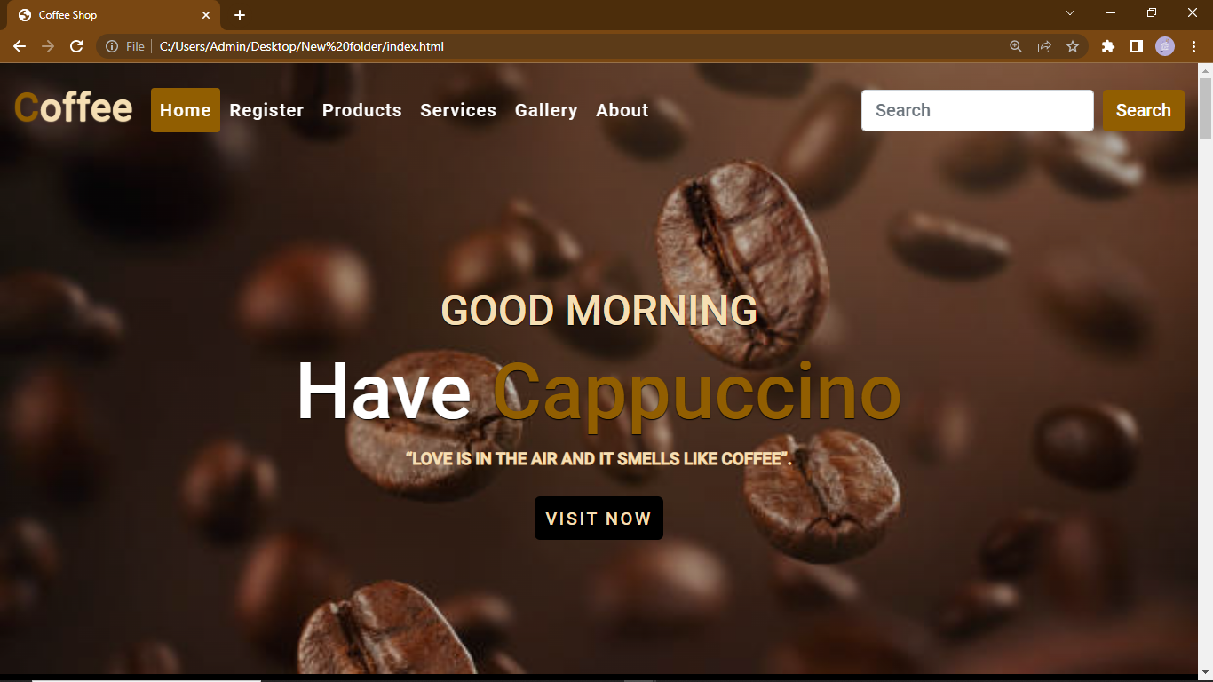

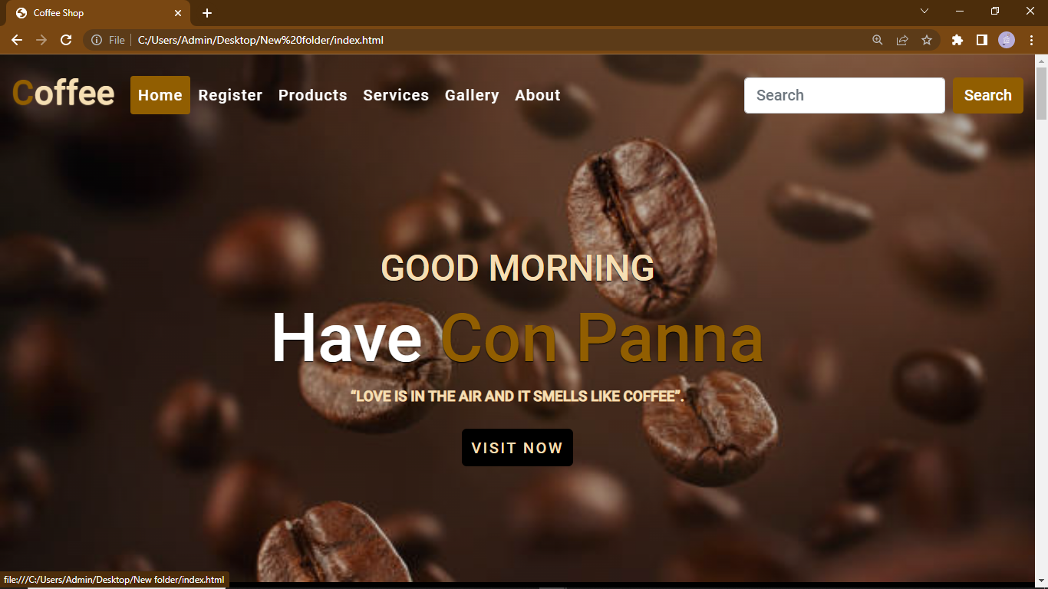

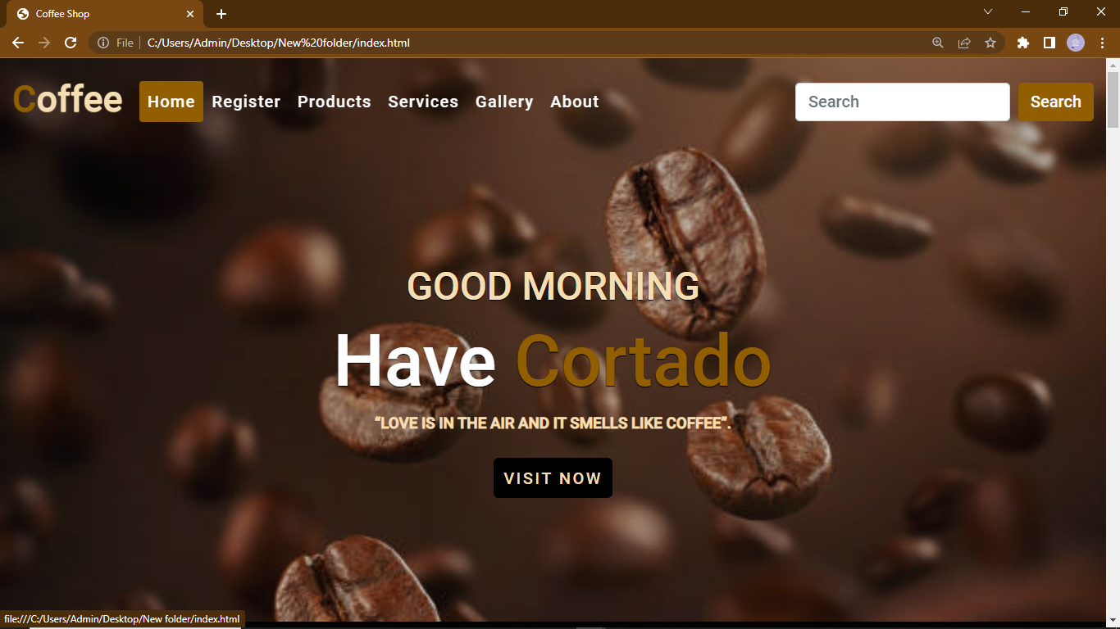

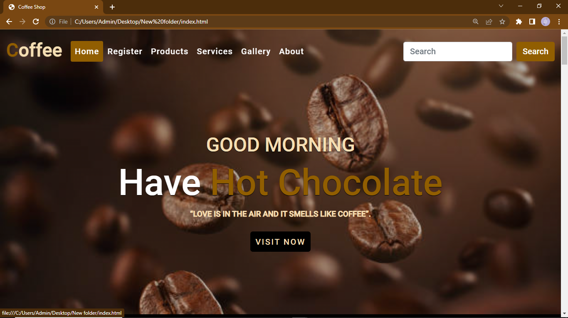

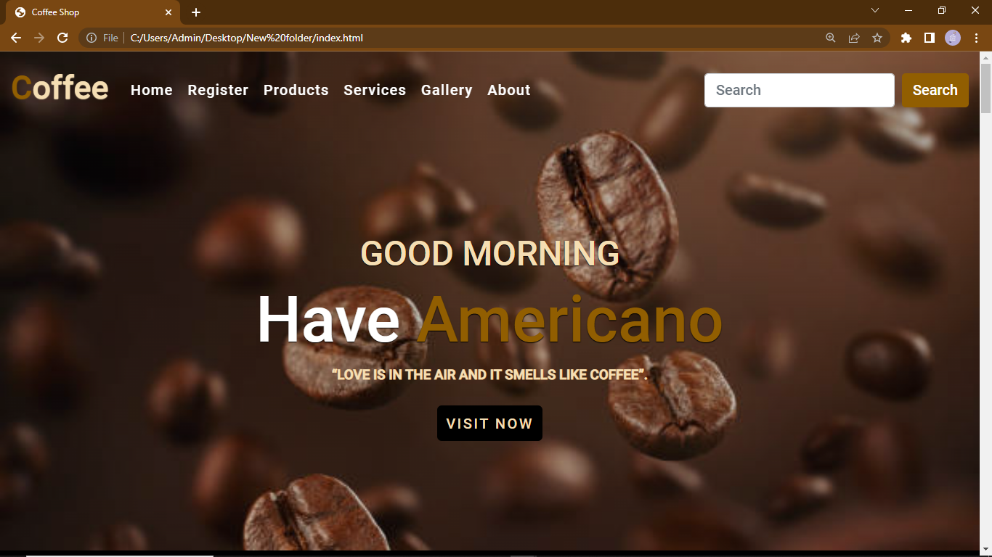

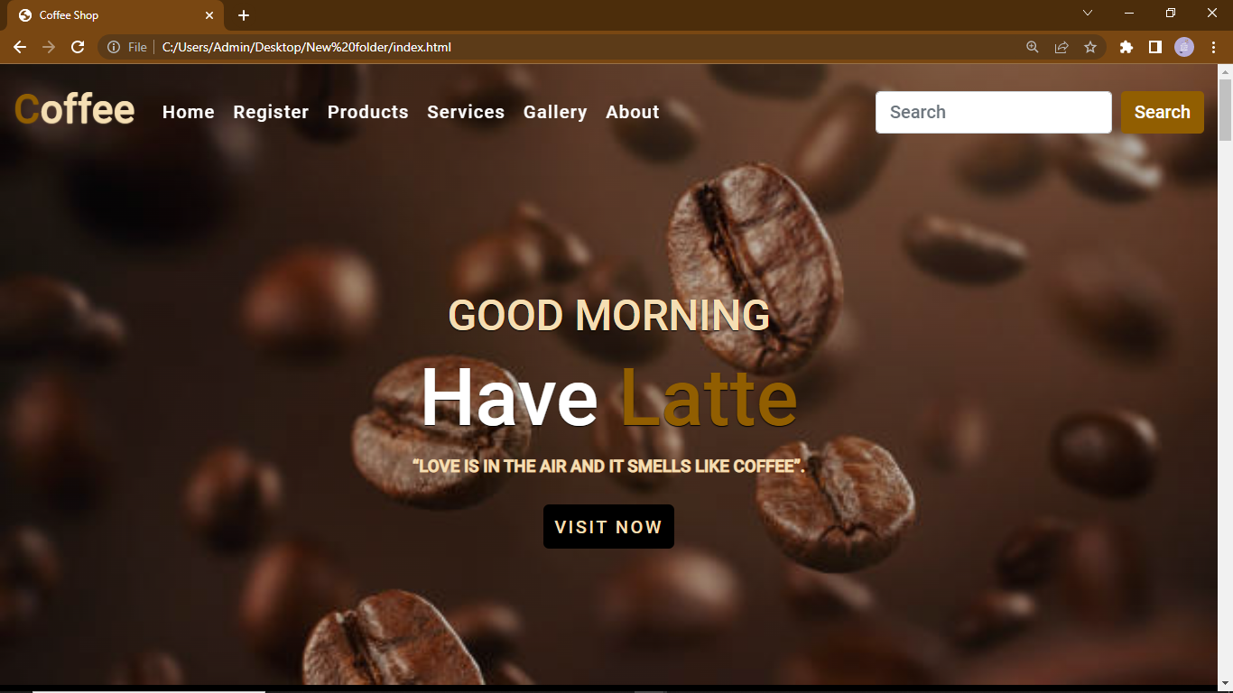

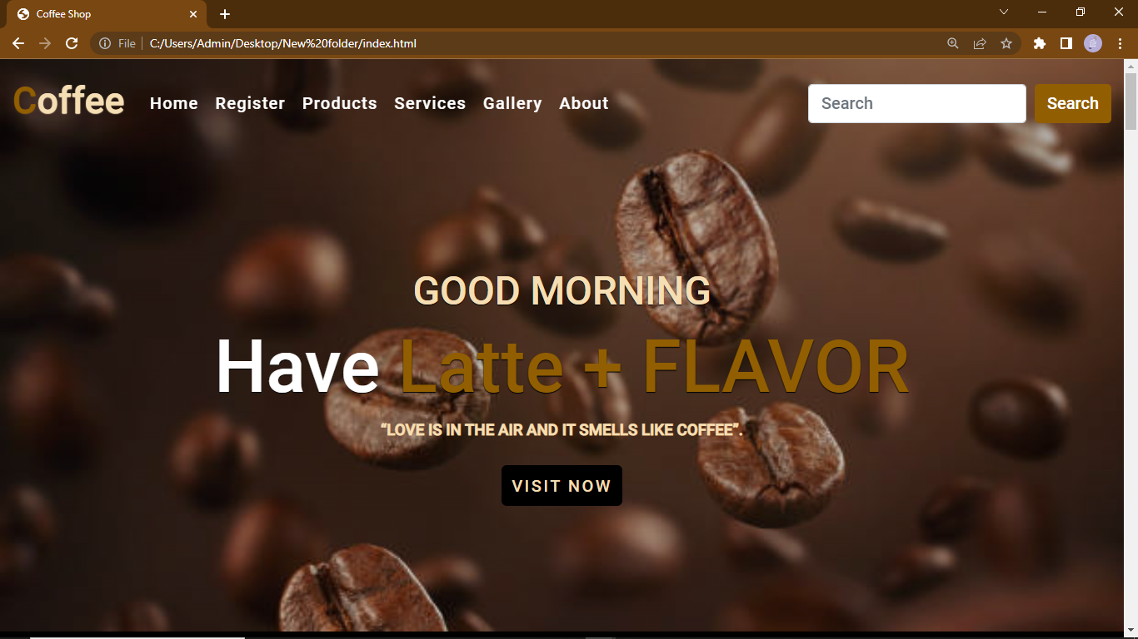

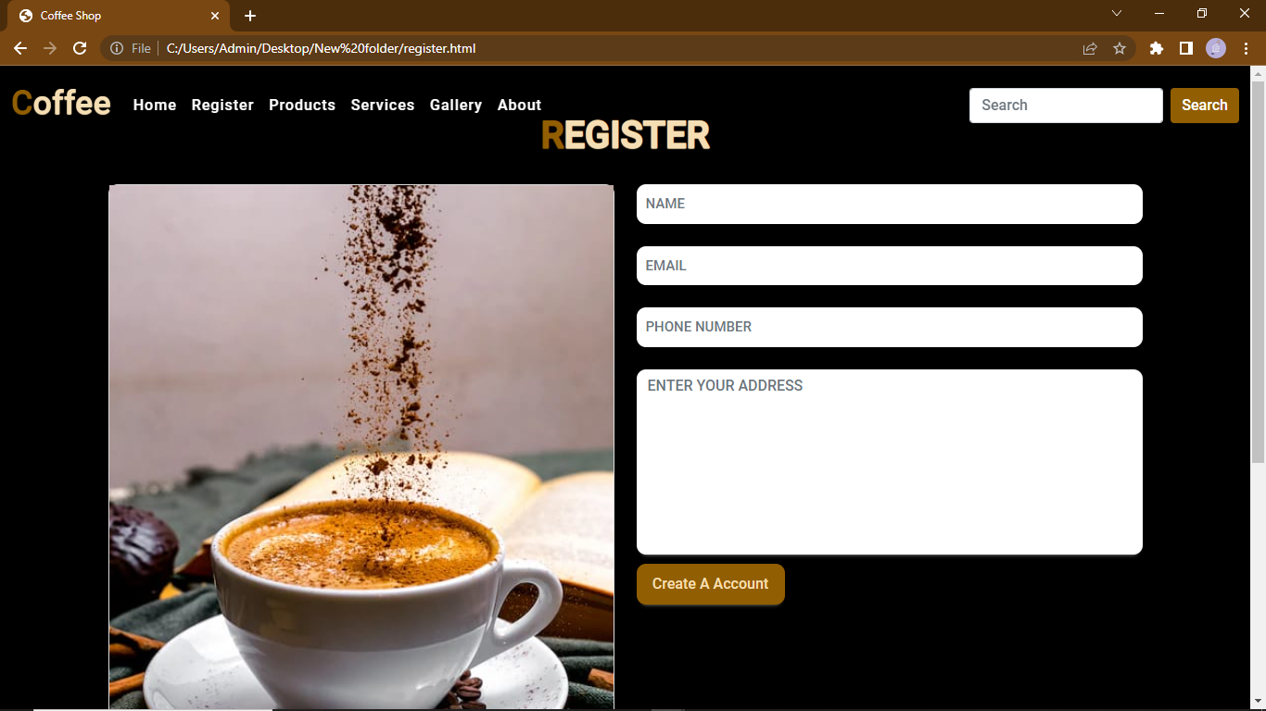

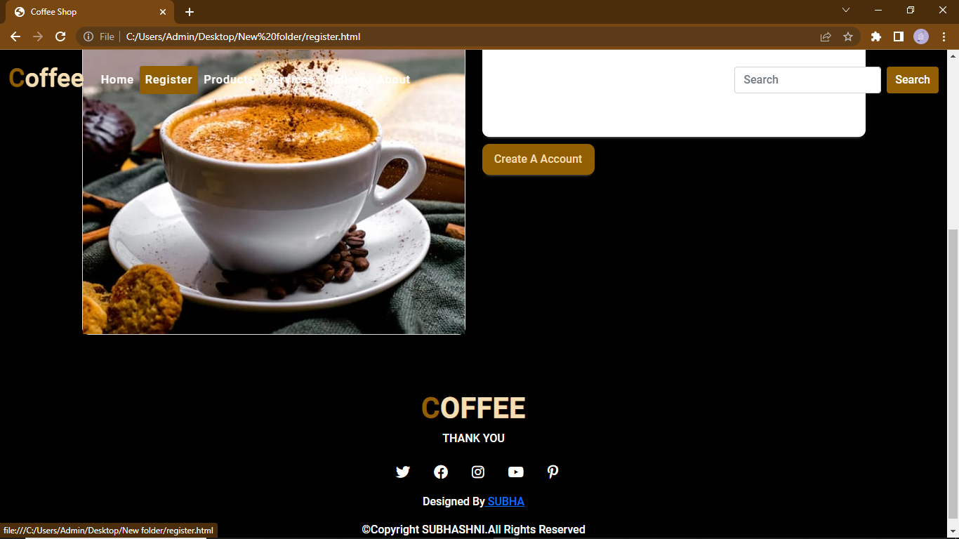

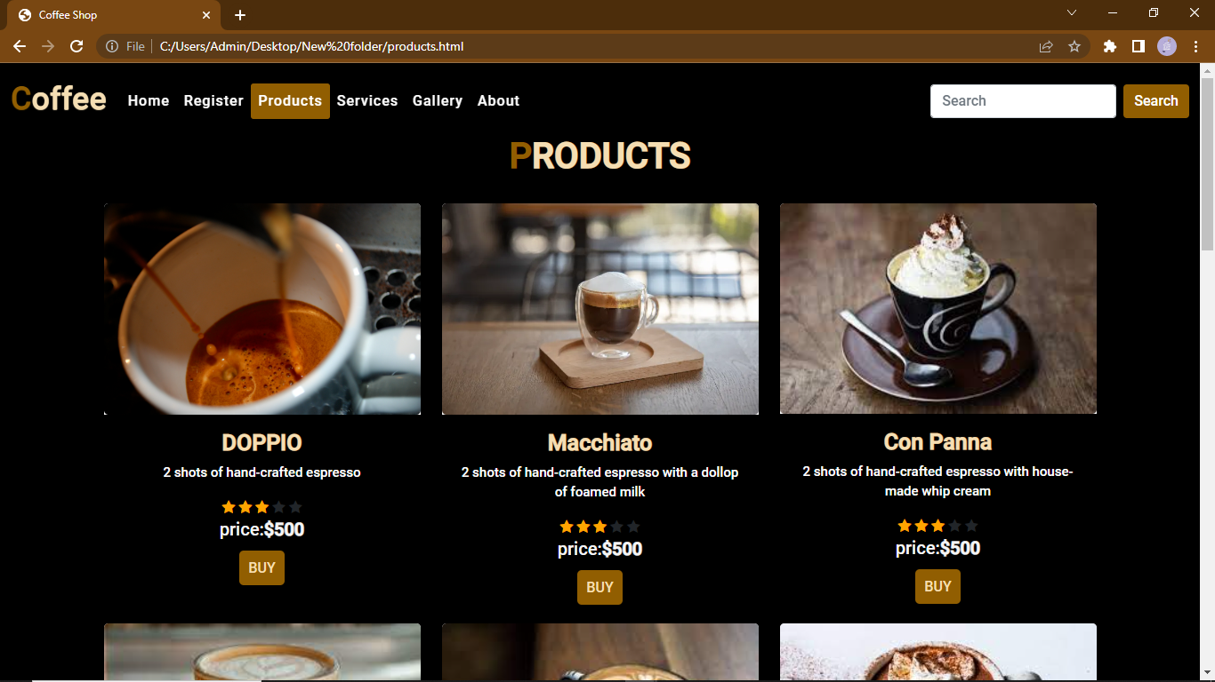

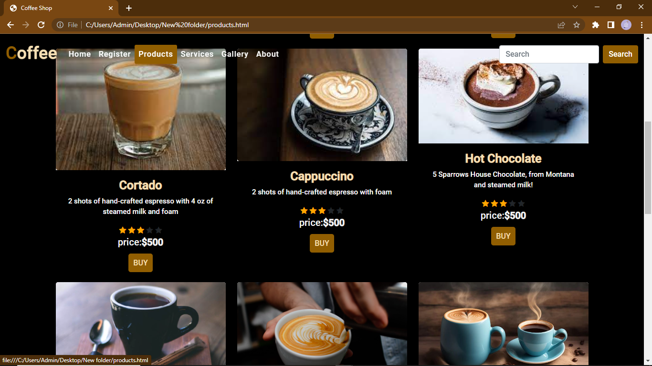

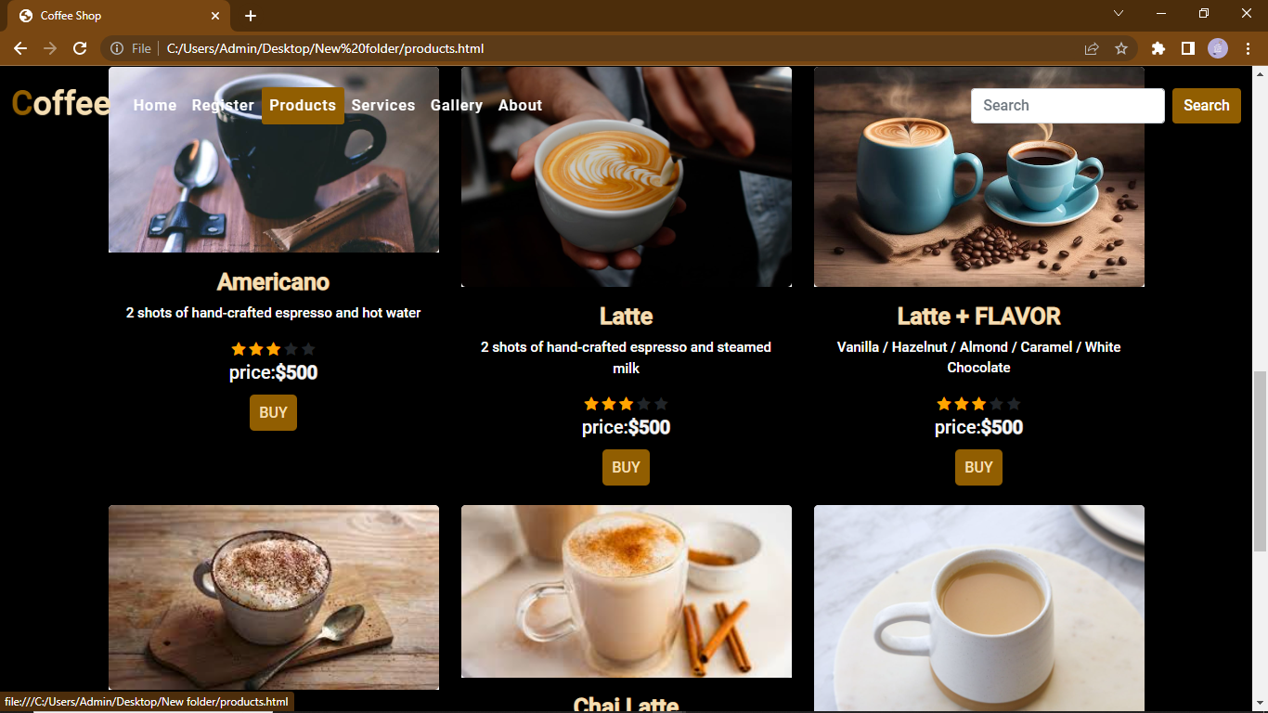

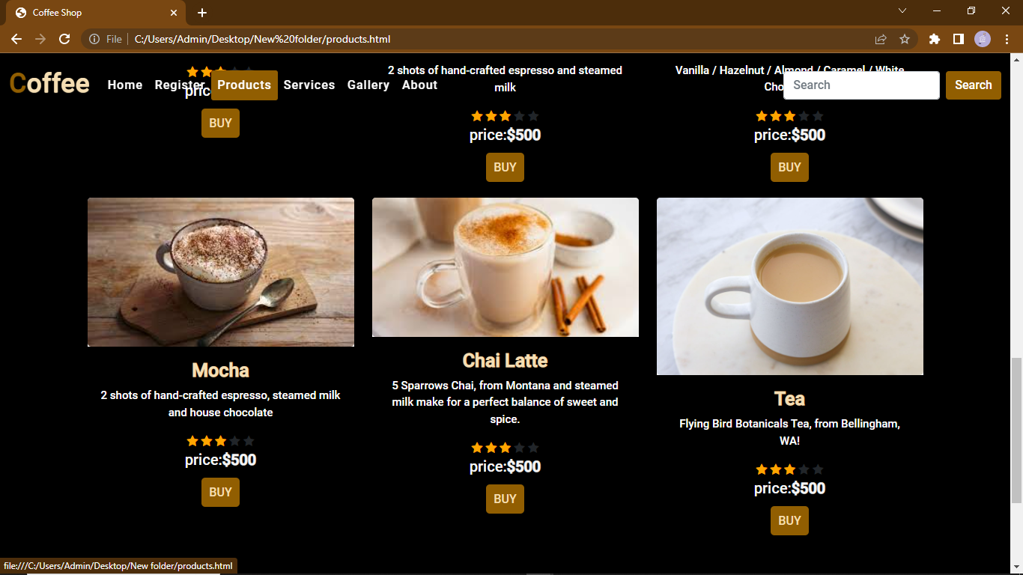

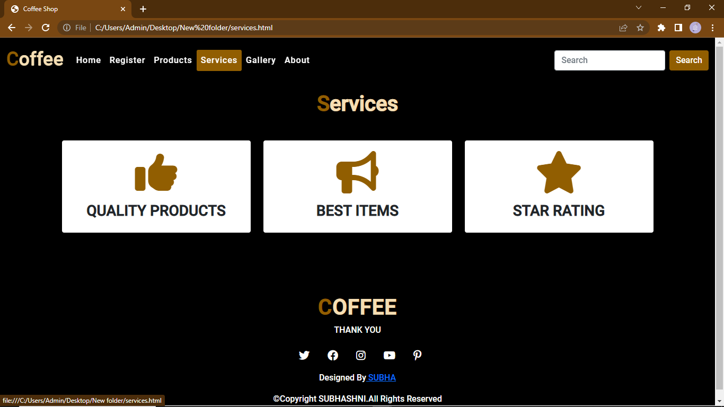

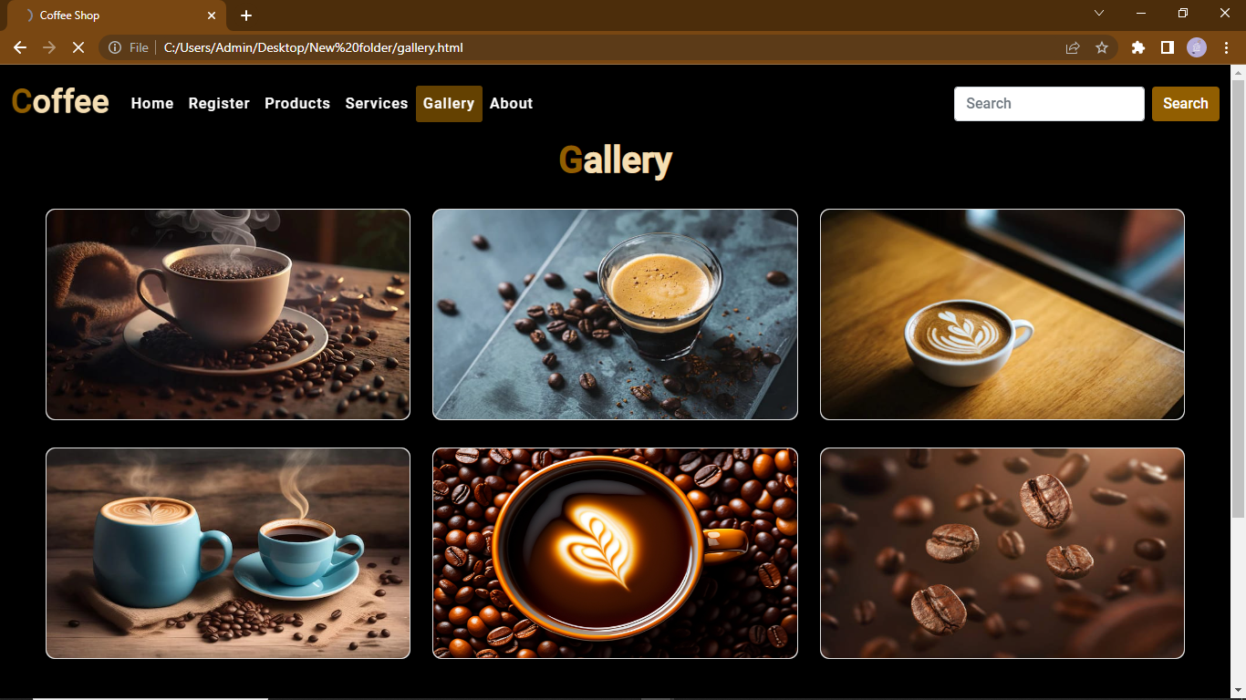

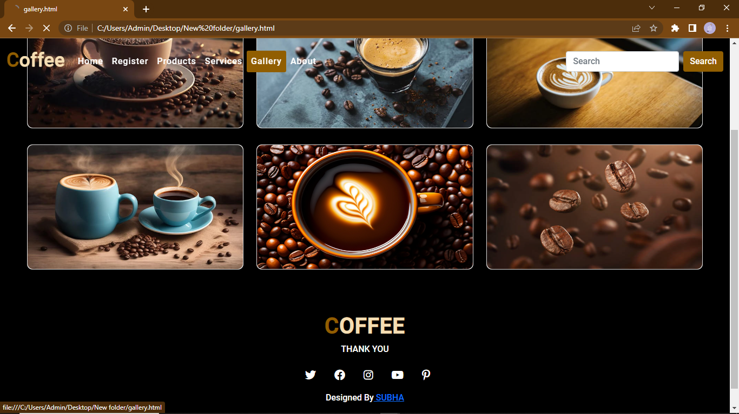

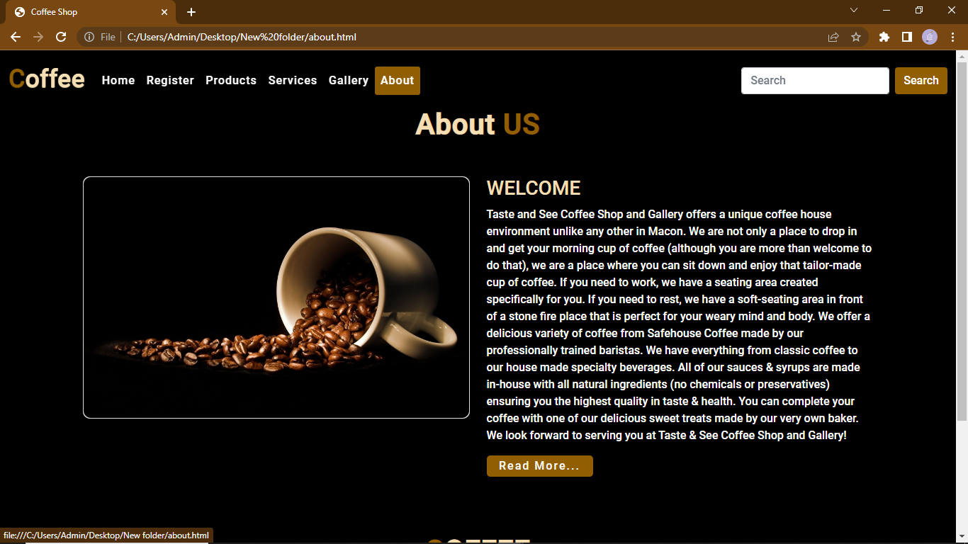

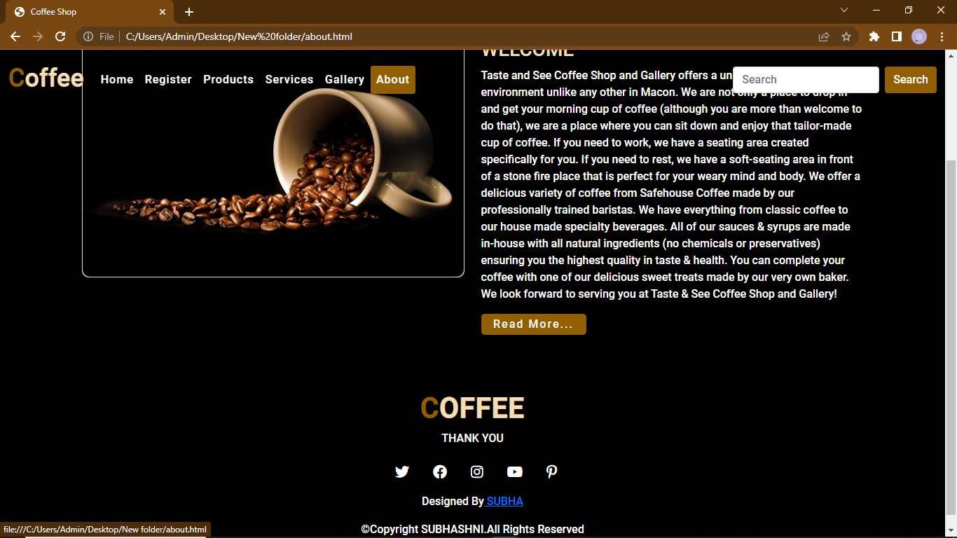

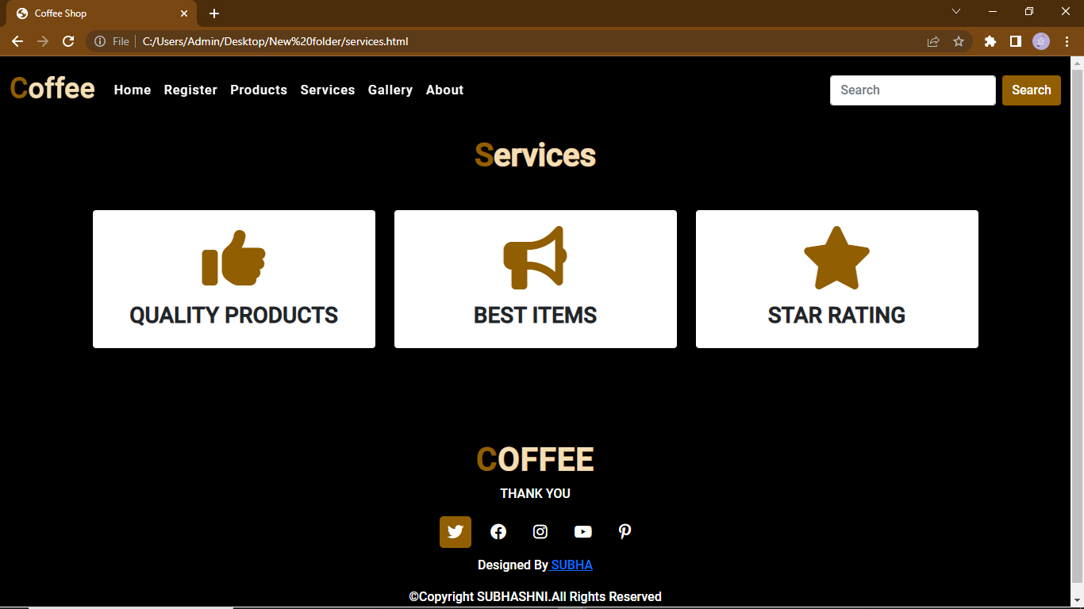

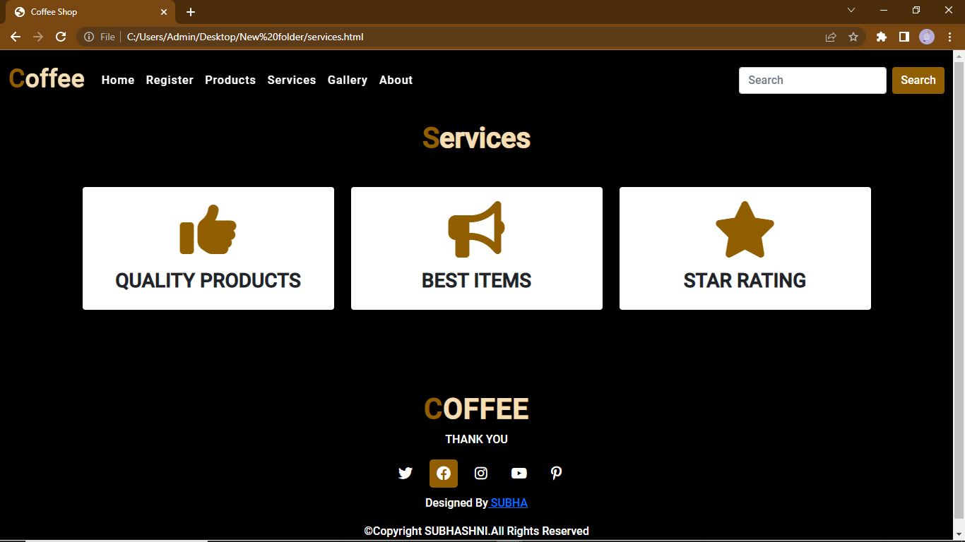

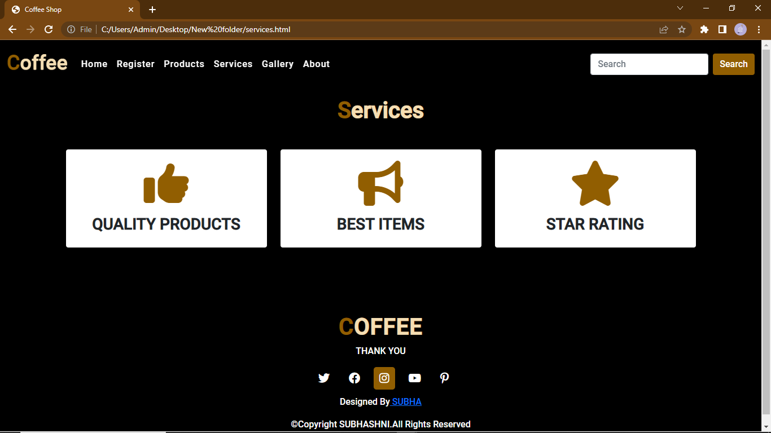

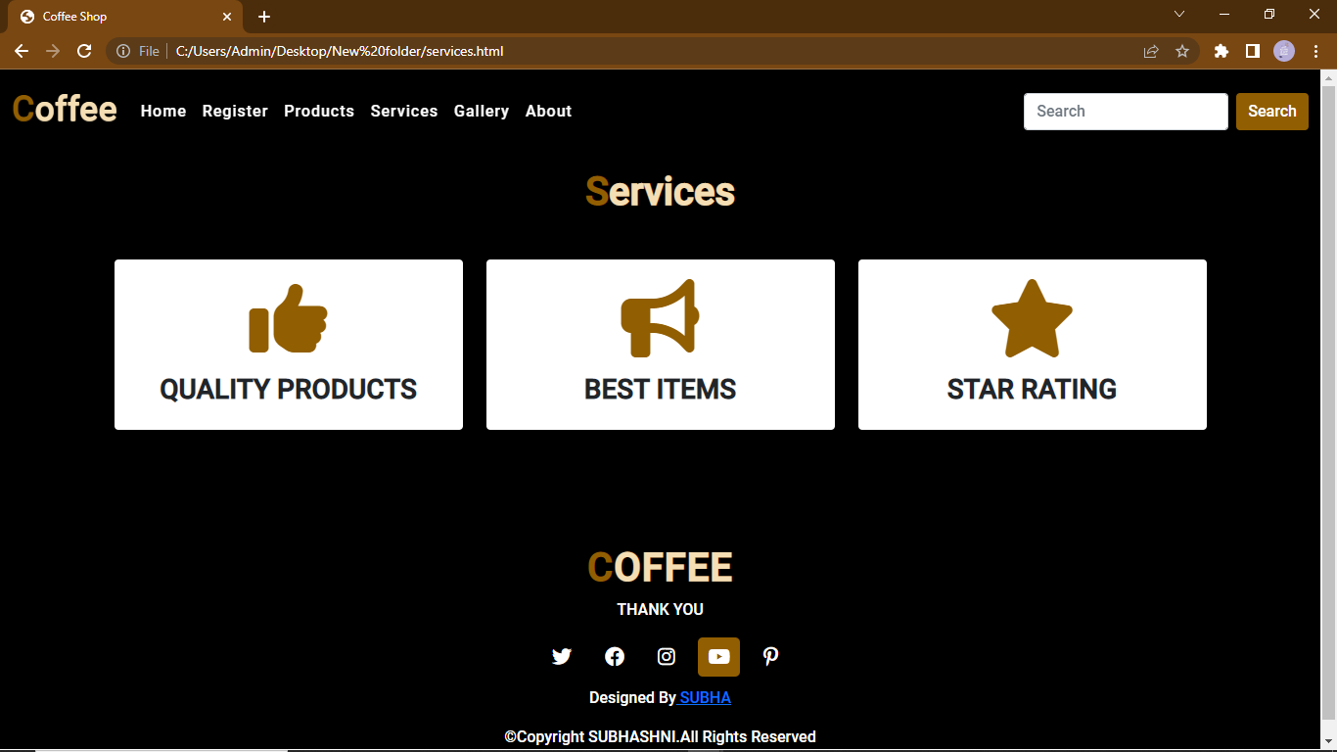

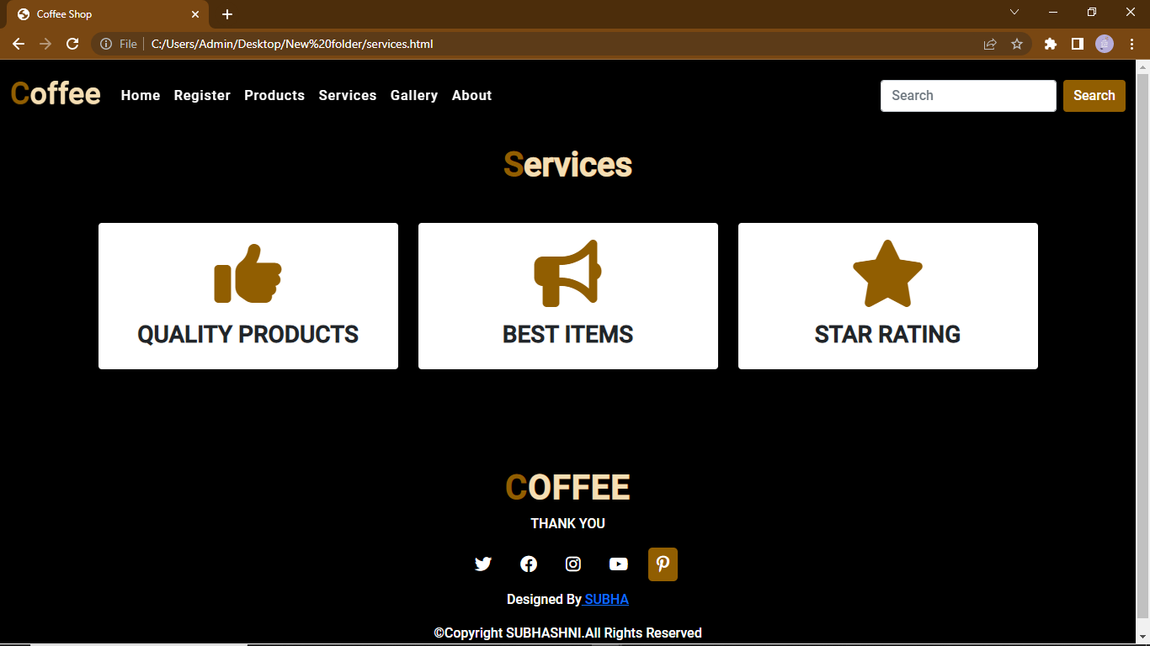

THANK YOU